Global Water Safety

Conference 2016
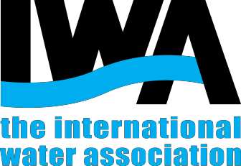

Call for papers

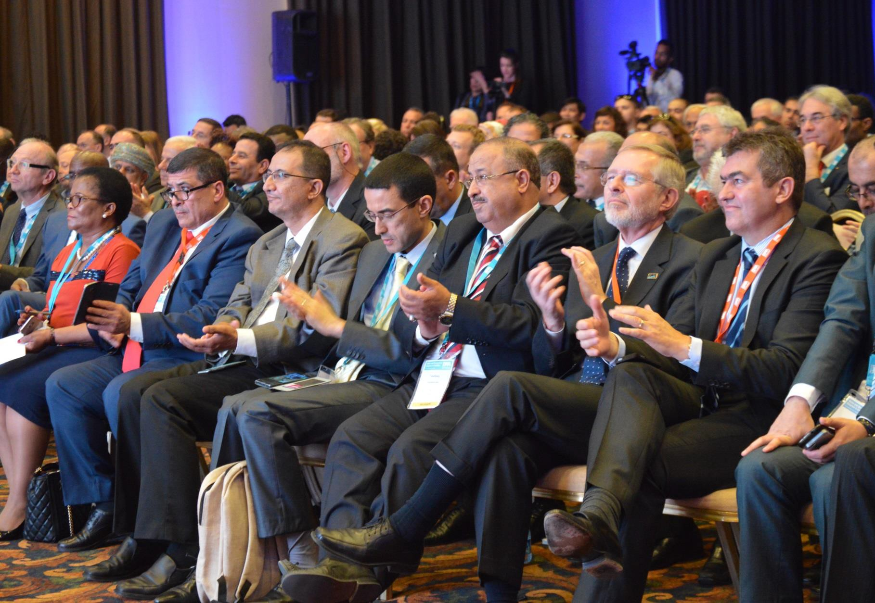

25- 28 APRIL 2016,

PALAWAN, PHILIPPINES

www.iwa-network.org/events/global-water-safety-conference

Water Safety Planning:

A pathway to universal access to safe drinking water and sanitation and improved service delivery

Water Safety Planning (WSP) is increasingly considered the best practice for ensuring the supply of safe and clean drinking water. However, it is critical to accelerate the adoption of water safety plans to guarantee progress on the realisation of the Sustainable Development Goals as well as the human right to safe drinking water. But what is it required to speed up the implementation of water safety plans?

Building upon past initiatives that put water safety plans high in the policy agenda, the International Water Association (IWA) and the Philippines Water Works Association (PWWA) in collaboration with the World Health Organisation (WHO) are organising the Global Water Safety Conference: A pathway to universal access of safe drinking water and sanitation and improved service delivery, from 25 to 28 April 2016 in Puerto Princesa City, Palawan, Philippines. The main objective of the conference is to profile innovative regulatory and operational initiatives as well as capacity building approaches and other relevant tools that effectively enhance WSP implementation.

Why submit your abstract?

▪ Present innovative solutions to the pressing, yet exhilarating challenge of meeting the Sustainable
Development Goals and the human right to safe drinking water.
▪ Validate and disseminate your work by presenting it to an audience of experts relevant to water safety.
▪ Connect with world leading water professionals and forge new partnership opportunities.

Programme Committee
▪
▪
▪
▪

Asoka Jayaratne, Yarra Valley Water (Chair) David Sutherland, WHO Neneth Javier, PWWA Alex von Hildebrand, WHO Roger Borja, PWWA Angella Rhinehold, WHO Fiorella Pollo, UNICEF
Pritha Hariram, IWA Rui Sancho, Aguas Do Algarve

Marie Sagen, IWA Rafael Bastos, University of Vicosa

* More Programme Committee members still to be confirmed

Topics

▪ Water Safety Plan Implementation: Benefits and Lessons Learned

▪ Innovative Policies and Regulations for Drinking Water Quality Management

▪ Risk-based Investment Planning for Water Supply Systems

▪ Operation and Maintenance of Water Supply Systems

▪ Auditing Water Safety Plans

▪ Improving Resilience to Climate Impacts from Catchment to Consumer

▪ Sanitation Safety Plan Implementation

▪ Integrating WSPs and SSPs: Opportunities, Examples and Lessons Learned

▪ WSPs for Small water supplies

▪ Water Safety Plan Impact Assessment

▪ Capacity building approaches on Water Safety Plans

▪ Approaches to sustainable scale up of Water Safety

▪ Equitable and Universal Access to Safe Drinking Water: Approaches, Initiatives and

Lessons Learned

Outline paper submission

Submission

Outline paper submission shall be done via the IWA online submission system: CLICK HERE TO SUBMIT YOUR PAPER.
Please, fill in the form following the instructions for each new submission. To ensure that your paper has
been successfully submitted, remember to click the “finish” button at the end of the process.
In case you need to modify your submission, login in again by using your ID and password
at HERE. Remember that you can edit your submission until 31st December 2015, which is the date for sending it for review.

Topics: Confirm that topics (see above) fit your research.

File naming: File names will have to include the family name of the first author (eg. Suarez.doc).

Format: The outline paper should be uploaded onto the submission system as a Word file and it must follow the template.

Limitations: There is no limitation on the number of paper submitted per author; however, a maximum of two platform or three poster presentations by the same author will be accepted.

Publication: Accepted papers submitted via the IWA online submission system will be included in the conference proceedings and will be distributed to all registered conference participants (subject to the registration of at least one of the authors for the paper).

Platform presentations

Authors willing to have their papers considered for keynote or platform presentation will be required to submit a maximum of 2 A4 pages of text including the title, abstract, keywords and main text and 2 A4 pages for illustrations (i.e. tables, diagrams, graphs, etc), always respecting a limit of 1000 words. In order to speed up the review process, authors must ensure that their submitted papers are according to the template.

Poster presentations

Authors wishing to have their papers considered for poster presentation are required to submit a total of 2
A4 pages (including figures, tables and references) according to the template.

Full paper submission

After the peer-review process, the highest quality papers will be selected and authors will receive an invitation to develop full manuscripts to be submitted for publication in one of the IWA journals
(namely: Water Science and Technology; Water Science and Technology: Water Supply; Journal of Water Reuse and Desalination; or Journal of Hydroinformatics). Please note that acceptance of a paper for conference presentation does not guarantee subsequent acceptance for journal publication, the final decision on journal publication lies with the journals' Editor-in-Chief.

Once the outline paper is selected for either platform or poster presentation, at least one of the authors must register for the conference (before Early Bird Registration deadline in order to be included in the conference program) and present the paper at the conference.

For additional information and updates, visit http://www.iwa-network.org/events/global-water-safety­
conference

