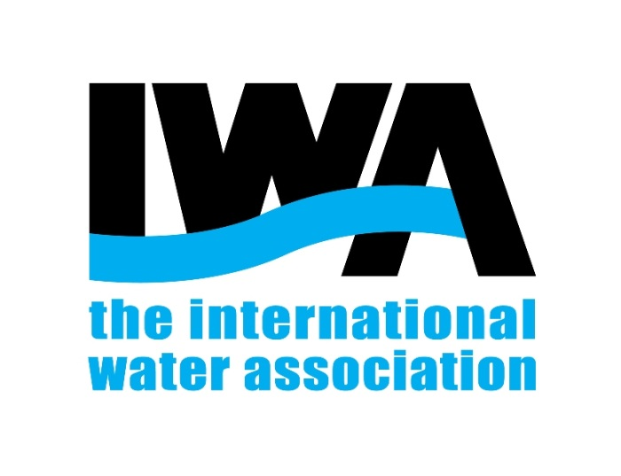
The International Water Association

PROPOSAL FOR IWA SUPPORT

Full Title
Date of the event ; City, Country
Organised by: Name
29 August 2017
The following proposal form will provide The International Water Association enough information about the event in order to be evaluated by the IWA Events Programme Committee. We encourage the proposers to complete the form as much accurate as possible to provide us a good prospect of the event features.
Please complete this as fully as possible and e-mail to IWA: conferences@iwahq.org
IWA, Anna van Buerenplein 48, 11th floor, 2595 DA, The Hague, The Netherlands
Telephone: +31 (0) 70 3150 792.

- Event details
Full Title | Full title |  |  | Short Title | Insert short title
Type of event | Choose the type of event
Exhibition? | Does your event include a trade fair or Exhibition? if yes, please indicate numbers of visitors and exhibitors
Conference Series? | If Yes, please identify previous conferences with dates and venues.
Location (City, Country) | City, Country | Scope | Choose an item.
Dates of the event | Date of the event
Expected number of delegates | Total number of delegates
Event Website Address | Website
- Organizer Details
First Name, Last name | Name | Email | Email
Address, Country | Address, Country | Phone | Phone number
Affiliation | Organization, Company… | IWA member
Co-organisers | Please indicate the name of other institutions, organisations or companies that are co-organising the event

- Event Content
Classify your event in the appropriate thematic area/s (please tick the box/es )
☐ Basins and Water Resources |  | ☐ Urban Water Management
☐ Drinking Water Systems |  | ☐ Wastewater Systems (small scale)
☐ Industrial Water and Wastewater |  | ☐ Wastewater Systems (large scale)
☐ Information and Communications Technology |  | ☐ Water and Health
☐ Resource Recovery and Reuse |  | ☐ Water Governance, Regulation and Utility Management
☐ Treatment Technologies

Description of the event
Please describe your event indicating the reason behind IWA should support the event.
Click here to enter text, max 150 words.

Please send it to conferences@iwahq.org , we will contact you within the next 2 weeks.

