IWA Leap - Leadership Programme for Young Water Professionals
Readiness Questionnaire
Welcome to the IWA Leadership Programme for Young Water Professionals Readiness Questionnaire.
This is an opportunity for you to understand the five conditions of success and to assess whether this is currently the right programme for you.
The IWA LeaP will explore different aspects of leadership and participants will need to have had enough experience for there to be a grounding on which they can develop. In addition to this, they will be required to put the learning into practice within their existing roles and therefore, they will need to have a role that requires them to interact actively with different stakeholders and have enough opportunities to challenge themselves to grow as a leader in their own field.
This document is just for you, and we will not ask you to share. It simply gives you the opportunity to reflect and decide if it’s right for you to apply to the IWA LeaP now or whether there is more value in applying at a later date. We value your skills, qualities and passion; our aim is to make sure everything is in place for you to thrive.
This document captures the five conditions needed for you to be able to get the most out of the programme:
- Experience
- Availability
- Desire
- Open-mindedness
- Support
Look at the five questions below, be as honest as you can because your answers are for your own reflection.
Observe if you find the process difficult or some of the questions and answers challenging, it’s all part of the journey!
To help, after each question, we’ve shared ways that have supported others to succeed in these areas.

1. Experience

What experience have you had in your professional and personal journey so far, that has allowed you to understand and express your own leadership?
This is not related to hierarchy or levels of responsibility in an organisation but more examples of situations where you have had to drive change. It includes situations where you have had to influence multiple stakeholders, manage complex situations, manage others (even if they are not formally reporting into you …). It means that you have begun to explore how you turn up as a leader, sometimes with the challenges this might bring.
Take some time to write these down. You can use the box below.

2. Availability

How are you going to make yourself available to fully participate on the programme?
Score yourself on a scale of 1 to 4 where:
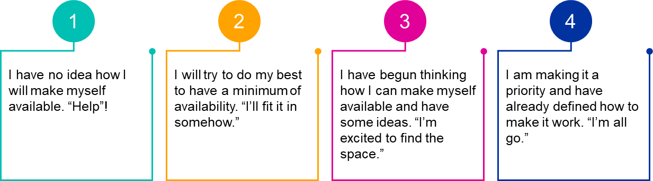

Your score =

Ways you might reach a ‘3’ or ‘4’
No judgment on this but we know that participants often find it difficult to make learning a priority. Our goal for you is between 3 and 4. Here are some ideas to shift towards the higher scores:
- Put dedicated personal development time in your diary every week as well as the events – we also encourage you to take 10 minutes a day to review and reflect, choose a time that works best for you;
- Block off two hours on the day before the retreat and/or the morning after to ease yourself back into your role with no meetings;
- We encourage you to participate in the virtual events from a space that is closed and private with no interruptions. If you can participate from home then please do so – organise your space by removing papers, placing some objects you like around you, making sure you have water and snacks you enjoy. If you need to work from the office, then ensure you book a closed space and are not in an open environment.
- Identify the tasks you can delegate and the people you can delegate them to, over this period – use this as a developmental opportunity for them and yourself;
- Look at those things you might be doing ‘very well’ and decide to do them ‘well enough’ instead – this might be a useful habit to form;
- Analyse tasks using the DO, DELEGATE, DELAY and DROP categories;
- Give yourself permission to say NO to something or to ask to put an initiative on hold for the purpose of putting your own leadership first – try it, you might like it!
- Come up with your own strategies to make the space you need – we look forward to sharing these when we meet.
Take some time to reflect on the above, then write down what are you going to do to make yourself available for the programme. You can use the box below.

3. Desire

How keen are you to participate in the programme?
Score yourself on a scale of 1 to 4 where:
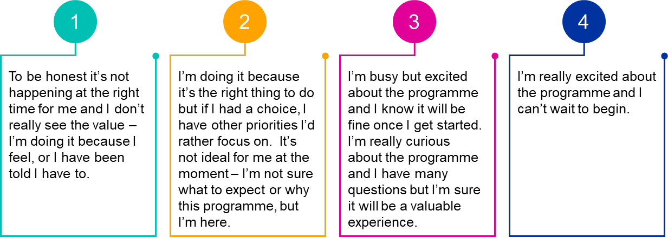

Your score =

Ways you might reach a ‘3’ or ‘4’
One of the challenges we know as leaders is that we don’t put our own development as a priority – there is always something more important to focus on. We often ‘turn up’ without giving thought to the questions we have or how to really maximise the opportunity. We invite you to explore what you can do to make this programme work for you. Here are some ideas:
- What is the example you are setting to others in making your growth a priority?
- When was the last time you invested in your own growth and development?
- Build the link between this programme and positioning yourself strategically within the organisation for the benefit of yourself, but also your teams and your stakeholders;
- What questions do you have about the programme? What would you like to get from it?
- Gather input from others about what they see as your strengths and how you might like to develop as a leader – identify the benefits of the programme for them and for you;
- Recognise that being on this kind of programme might also give you a chance to take a step back as a leader which is often a rare and appreciated opportunity;
- We know that the current situation has put leaders under huge pressure, but we also know that we need to look after ourselves and find new perspectives to be able to be the change agents our organisations need moving forward;
- Finally, if you're really struggling with participation, speak to your programme sponsor or one of the facilitators to explore in more detail.
Take some time to reflect on the above. You can then use the box below to collect your thoughts or actions related to this.

4. Open-mindedness

How able am I to explore new ideas, step out of my comfort zone and experiment new ways of being and doing at the moment?

(We ask ‘at the moment’ as this can be a function of where we are in our lives rather than a fulltime mindset.)
Score yourself on a scale of 1 to 4 where:
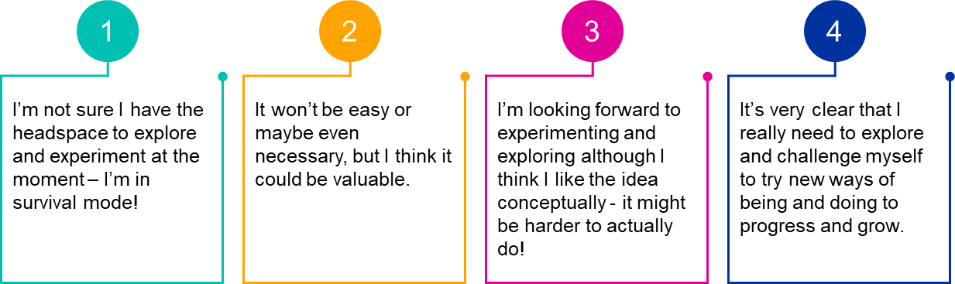

Your score =

Ways you might reach a ‘3’ or ‘4’
We often say we have an open mindset but the reality is that all kinds of things can get in the way of us changing our behaviours – being overwhelmed, being comfortable, being afraid, having other priorities, not having the desire or seeing the value in change. Think about where you are and how you can shift towards a 3 or 4.
The programme is very experiential and so key learning, individually and collectively, comes from stepping out of our comfort zones.
What could be valuable for you in doing this? How can we support you to make this happen?

5. Support

What level of support do I have to ensure I can participate fully in the programme?
Score yourself on a scale of 1 to 4 where:
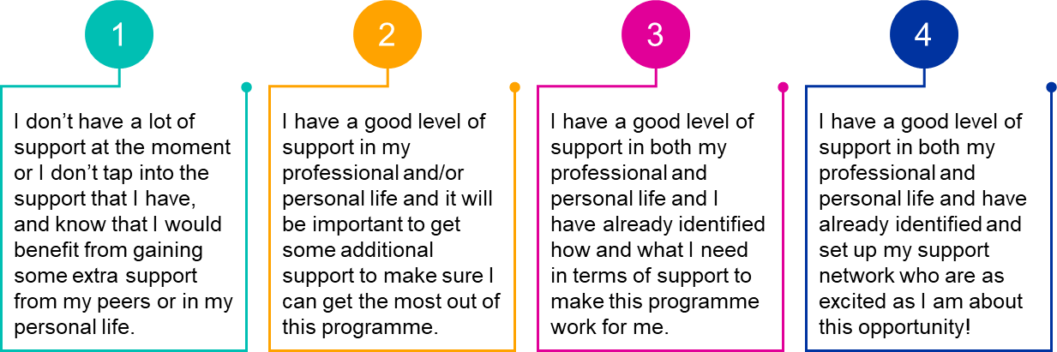

Your score =

Ways you might reach a ‘3’ or ‘4’
When participants embark on a learning programme such as this one, we know that the success of the programme is affected by the level of support participants receive or ask for. It comes in all kinds of forms:
- Emotional support and encouragement to dare to try new things.
- Practical support to ensure that you have the necessary time to focus on your learning.
- Logistical support to ensure you have the space you need for the live labs.
- Networking resources to ensure that you can explore new horizons.
- Team support to ensure that you don’t have to manage non-essential issues.
Think about your own situation and explore what you need to do to make sure you are creating the best conditions for your own journey. What do you need to do?

This concludes the readiness questionnaire. Take a moment to review your answers and reflect on your responses. Consider whether this is the right time for you to join the IWA LeaP and embark on this transformative journey. Your thoughtful reflection will help ensure you are fully prepared to embrace the opportunities and challenges that lie ahead.
If you require more information, please contact ywp@iwahq.org

